Display_Name..
Computer Programming Using Kivy - OpenGL 3 - Walkmeshes
GOAL: use the Glops 3D engine to use a walkmesh that limits where the player can walk.

(You must first have a completed and working opengl1.py)
Update the 3D engine:
- Go to your home drive (File Explorer, Computer, T:\username or H:)
- Go to your opengl folder, then double-click update-kivyglops

Get the exact name of the floor mesh then call the use_walkmesh method to make the game engine limit where the player can walk:
- Open Geany
- File, Open, your home drive (such as T:\username or H:), opengl, opengl1.py
- File, Save As, go to your opengl folder, then name this file opengl3.py
- Add the following to your load_glops method:

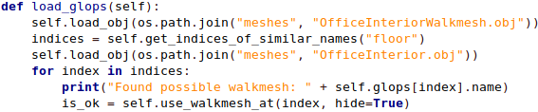

Execute the program. Now you should be able to walk around and go up and down the stairs!

BONUS: Find or make your own scene, then set at least one surface as a walkmesh (remember to name your objects before exporting if you are making your own mesh in a program such as Blender).

